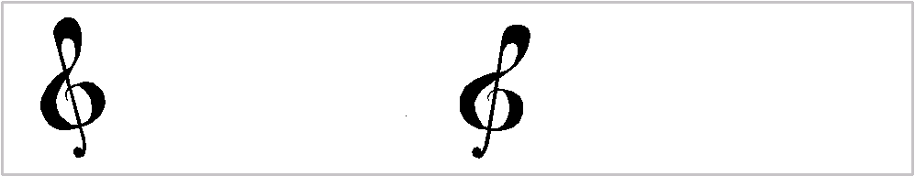

Orchard Middle School Music Department
6800 SOM Center Road
Solon, Ohio 44139
(440) 349-7707

Program Exit Form

It has come to our attention that your child no longer has the desire to be a part of the Solon City Schools’ String Program. Although there is a place in our program for every child, we understand that they have other interests and not every child can/will put the time and energy into practicing their instrument.
In order to serve our students better and improve the program we require that you help your child fill out this form and then sign at the bottom. Please answer honestly as we use this information to assess our program’s strengths and areas of needed improvement.

NAME______________________ INSTRUMENT _______________________ TEAM_____

Did you have a regularly set practice time during the day? Yes or No (circle one)

How many days a week did you set time aside to practice? _____

On average, how many minutes a day did you practice? _____

Did you ever take private lessons outside of school? Yes or No (circle one)

What made you choose your instrument? _____________________________________

Please give us some insight as to why you wish to “retire” from the strings program:

What was your best memory/experience in strings? Worst experience?

By signing this you are forfeiting your place in the Solon City Schools Strings Program and all the rights and responsibilities that it provides. Once you exit (retire) from the program you cannot re-enter unless you take a year of private lessons on a program approved instrument and successfully complete an audition for the string staff.

_______________________ ____________________________ _______________
Student’s signature Parent/Guardian’s Signature Date

